Keep fit and healthy.
Цель урока: Обобщающее повторение изученного материала по теме «Keep fit and healthy»
Задача урока: Активизация изученной лексики, совершенствование лексико-грамматических навыков, навыка аудирования, диалогической речи, подготовка к монологическим высказываниям.
Воспитательные задачи: формировать навыки здорового образа жизни.

Ход урока.
I. Организационный момент и речевая разминка.
-Hello, everybody! (Good morning, teacher!)
-I am glad to see you (We’re glad to see you, too.)
-How are you today? (We are fine, thank you. How are you?)
-I am fine, thanks. How’s the weather today? (It is not sunny .It is cool.)
-Who is absent today? (N. is absent. She is ill.)
-Poor N., sorry to hear that.

II. Сообщение целей урока.
-Today we are going to speak about health and healthy lifestyle.

III. Физкультминутка.
-Do you want to keep fit? To keep fit means to be strong, so let start doing morning exercises.
Stand up, please and do morning exercises with me:
Touch you shoulders
Touch you nose,
Touch you ears,
Touch you toes
Raise your hands
High up in the air,
To the sides,
On you hair.
Raise your hands
As before,
While you clap 1,2,3,4.
-Well done. Sit down, please.

IV. Фоно-речевая зарядка.
1. -Now let’s do some phonetic exercises. Find words and divide them into two groups.

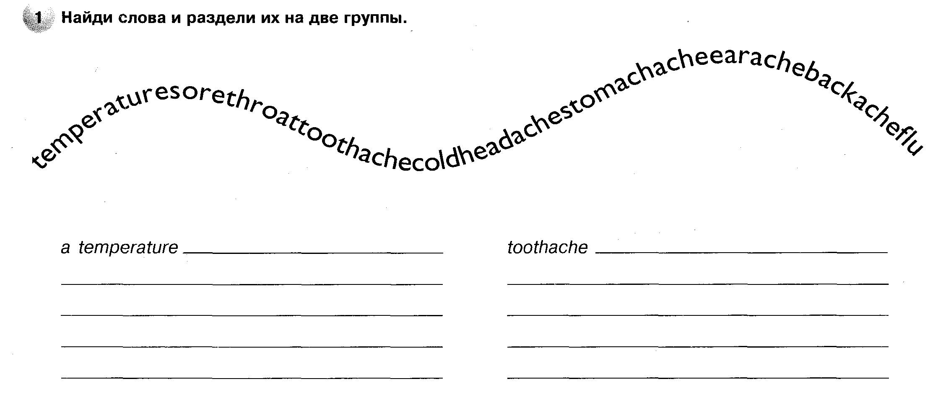
2. -Find words, read and translate them.
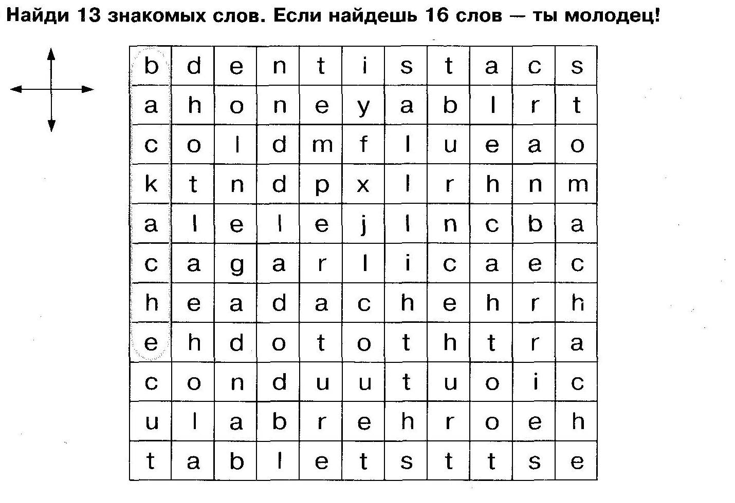
3. -Make phrases.
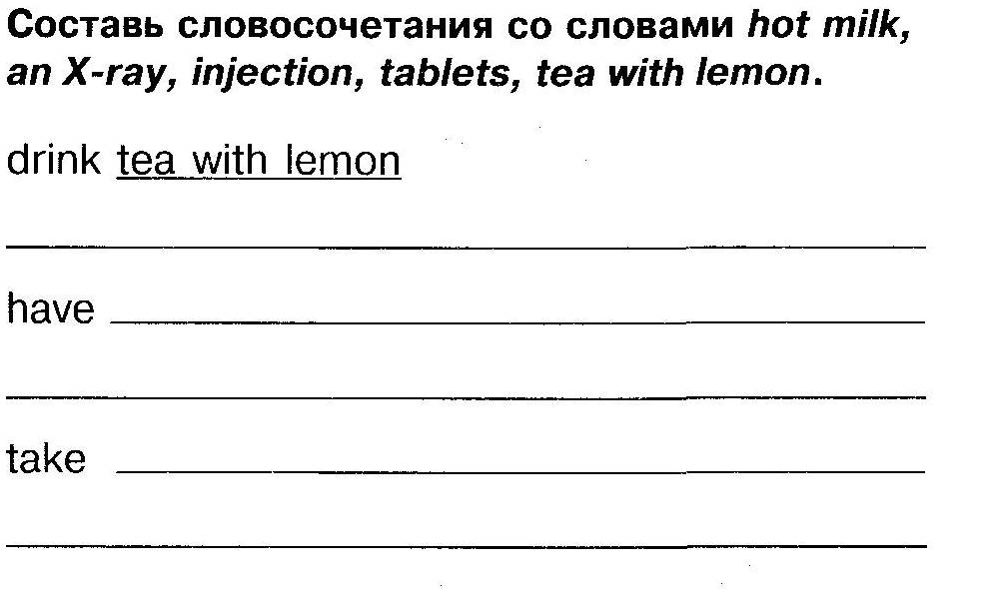

4. -Fill the table.
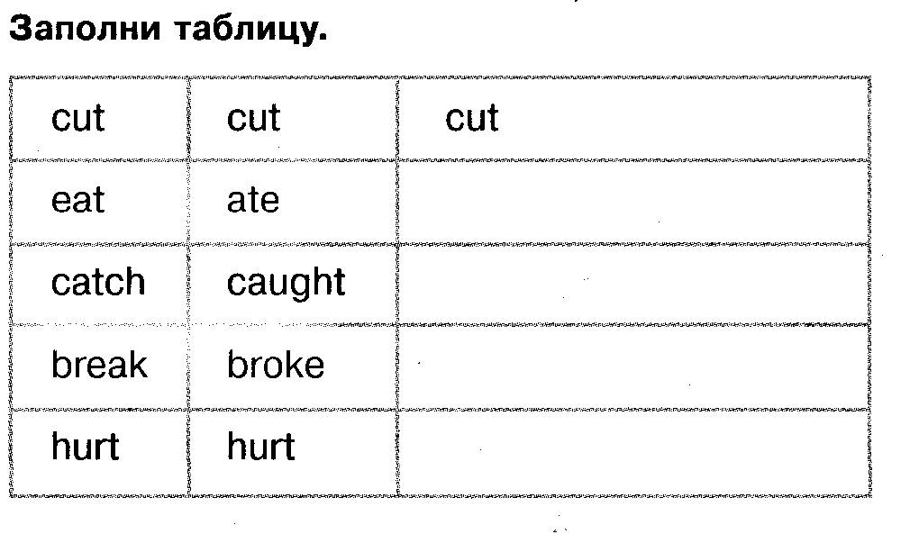

5. -Complete the sentences.
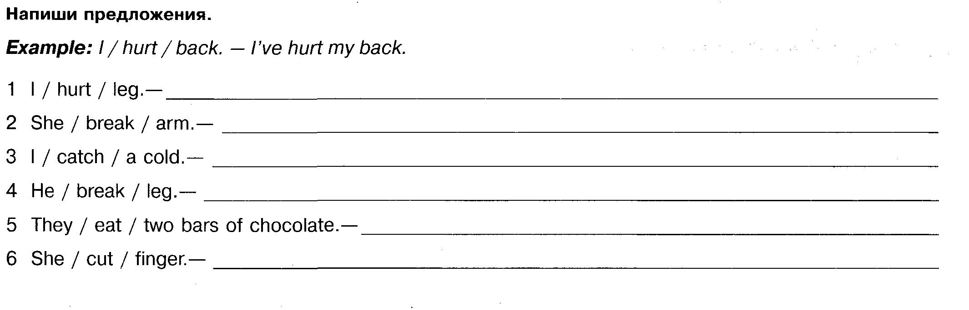6. -Translate into Russian.
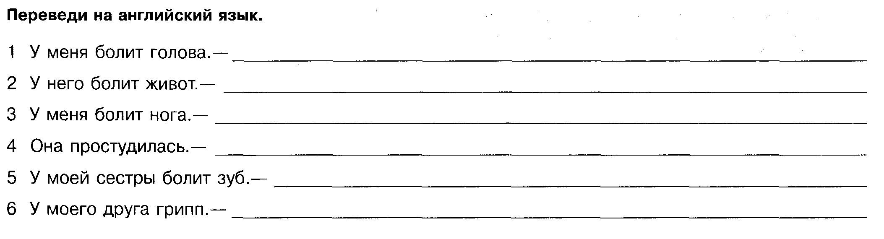7.
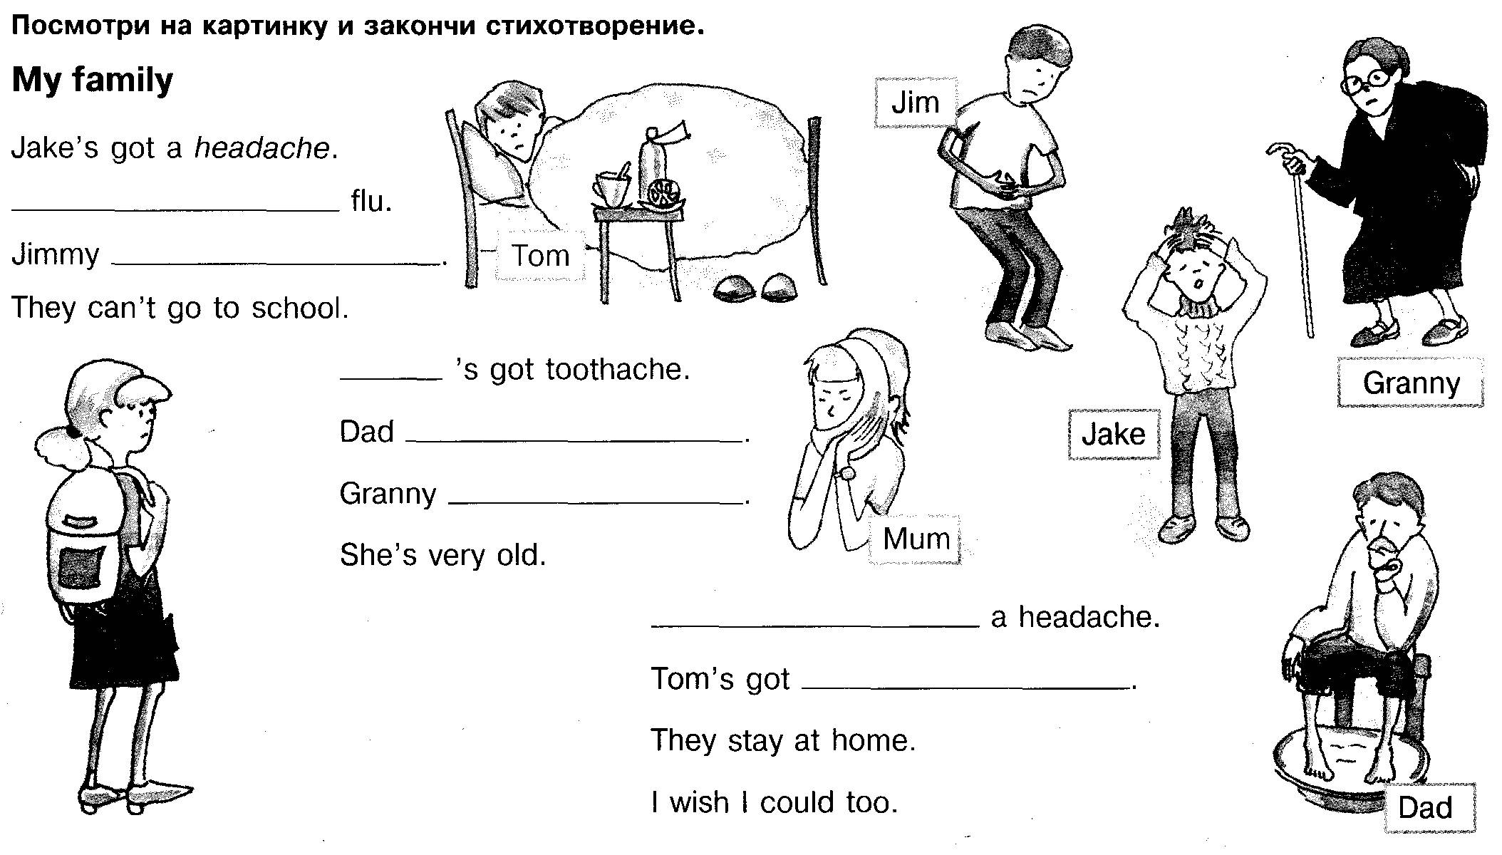

V. Контроль усвоения лексических единиц, совершенствование навыков чтения.
Работа с лимериком.
-Now you will read limericks. Limericks are humorous short poems with 5 lines, 3 long and 2 short. British people like limericks. Read and finish the lines with the name of illnesses to make a rhyme.

There once was a goat from Mars
He always ate chocolate bars
He ate a big cake
And got ...,
And now he only eats cars
There once was a bird from the Pole
She caught a very bad...
She went to nurse
And got even worse.
And now she does what she’s told.
There once was a man from Green Farm
He fell and...
He screamed every night
And called out in fright.
That poor man with a broken arm.

VI. Тренировка аудирования.
-Do you like humour? Humour can help people when they are not well. Listen to some jokes.

Joke 1:
A young man went to the doctor.
«Doctor, when I press with my finger here… it hurts,
and here… it hurts, and here… and here…. What’s
the matter with me?» he asked.
«You have a broken finger, » the doctor answered.

Joke 2:
«Boo-hoo! Boo-hoo! » little Bobby cried. «What’s
the matter, dear? » his mother asked. «Boo-hoo!
A picture fell and hurt Daddy’s head. » «Well, that’s
too bad, but you needn’t cry about it. » «I didn’t.
I laughed. Boo-hoo! »

Joke 3:
«Doctor, » a lady said entering the room, «tell me
what’s wrong with me. » He looked at her and said:
«Madam, I have three things to tell you: First, you
should sleep a lot. Your eyes are red. Second, you
should do exercises twice a day. You are too fat.
And third, I am an artist-the doctor lives on the
next floor.

-Was it funny? (Yes it was)
-Did you smile? (Yes we did)
-Do you like funny stories/jokes? (Yes, we do)
-How can humour help when we are not well?
(When you laugh, you feel better)
-Yes, laughter is the best medicine.

VII. Совершенствование грамматических структур Present Perfect, should/shouldn’t .
У врача (Дети получают карточки с проблемой)
-Role play. At the doctor’s
Pupil A: You are ill you visit the doctor and answer his/her questions.
Pupil B: You are a doctor. Ask your patient questions and give him/her advice.

A: Good morning, doctor.
D: Good morning. What’s the matter? (How can I help you)
A: I don’t feel well I’ve got a terrible headache and a sore throat.
D: Have you got a temperature.
A: Yes, doctor.
D: I think you’ve got flu. Take vitamins, keep warm and drink a lot of tea with lemon. You should stay in bed a sleep a lot.
A: Thank you, doctor.

(Карточки с «проблемами»: flu, a sore throat, a cold, a cut, a cough, a broken leg, a burn).

VIII. Физкультминутка.
My hands upon my head I place
On my sholders, on my face
Then I put them in front of me
And gently clap: 1, 2, 3.

IX. Песня «I don’t want».
-Sometimes children don’t want to have breakfast in the morning, they don’t want to clean teeth
and they don’t want to go to school. They say their mums that they are ill. Let’s sing the song:
«I don’t want».

- Every time I have a headache
Mama takes me to the doctor.
Every time I have a headache
Mama takes me to the doc.
I have a headache,
I have a headache
I don’t want to go to bed.
I have a headache,
I have a headache.
I don’t want to go to bed.

2. Every time I have a stomachache
Mama takes me to the doctor.
Every time I have a stomachache
Mama takes me to the doc.
I have a stomachache,
I have a stomachache.
I don’t want to eat my lunch.
I have a stomachache,
I have a stomachache.
I don’t want to eat my lunch.
3. Every time I have a toothache
Mama takes me to the dentist.
Every time I have a toothache
Mama takes me to the dentist.
I have a toothache,
I have a toothache.
I don’t want to clean my teeth.
I have a toothache,
I have a toothache.
I don’t want to clean my teeth.

X. Домашнее задание.
Выполнение проектов по теме.
We speak a lot about health today. Read these provebs and what do you think of them.
- Early to bed , early to rise, makes a man healthy, wealthy and wise.
- An apple a day keeps the doctor away.
- Health is better than wealth.

Ответы учеников:
-We should do morning exercises every day
- We should clean our teeth.
- We shouldn’t sit before TV all day long.
- We should go for a walk every day.
- We should sleep eight to nine hours a day.
- We should do sport.
- We should eat a lot of fruit and vegetables.
- We should eat healthy food.
- If we are ill we should visit the doctor.

T: Your home work is to make projects, posters in your groups:
How healthy are we?
How to be healthy?
If you have…, you should….

XI. Игра: Совершенствование знаний.
-To remember better the rules of healthy life style let’s play the game Fit or unfit. But first read these words by Henry P and translate his wise words.

